*Instruction*: **Answer all questions in this section.**

1. ________ is *not* an example of output device a. Monitor b. Microfilm c. Light pen d. Multimedia woofers
2. Which of the following is *not* a computer peripheral? a. Printer b. Mouse c. Keyboard d. Floppy
3. What does the term ‘hard copy ‘refer to? a. Memory output b. Scanned output c. Printed output d. Monitor output
4. Printed circuits, diodes and transistors first appeared in which generation? a. First b. Second c. Third d. Fourth
5. One of the following is *not* a feature of third generation of computers a. Procedural language b. Expert system c. Database concept d. Medium-scale integration
6. RAM is best described by the following attribute a. Volatile with read/ write access b. Volatile with read –only access c. Non-Volatile with read/ write access d. Non-Volatile with read –only access
7. Computer main memory is divided into a. ROM and PROM b. ROM and RAM c. RAM and EPROM d. ROM and READ
8. The component of third generation computer is

a. Vacuum tubes b. Integrated circuits

c. Transistors d. VLSI

1. Analog computers ______things a. Read b. Count c. Measure d. Manipulate
2. The fourth generation was based on integrated circuits a. True b. False c. None of the above d. Vacuum tubes
3. ____________ and __________ are the two types of software.

a. system and computer software

b. user and analog software

c. system and application software

d. none of the above

1. _______ Computer is a highly sophisticated and powerful machine that is used to perform complex calculation. a. Mainframe computer b. Digital computer c. Super computer d. Hybrid computer
2. _______ is *not* an example of a personal computer a. Notebook b. Desktop c. Palm top d. Mainframe
3. Which of the following gave birth to micro-processor? a. SSI b. MLS c. VLSI d. MSI
4. A computer system whose central processing unit is based on micro processor technology is known as a. Minicomputer b. Mainframe computer c. Micro computer d. Super computer
5. _________ is the lowest end of the computer range in terms of speed, cost and storage capacity. a. Minicomputer b. Micro computer c. Super computer d. Mainframe computer
6. When classifying computer by size________ computer has the largest size? a. Mini b. Mainframe c. Micro d. Super
7. The programming language employed in the second generation of computer was a. High level language b. Code language c. Assembly language d. Machine Language
8. Artificial intelligence is a notable characteristics of ______generation of computers a. 2nd b. 3th c. 4th d. 5th
9. Which of *these* computers operate on discrete values? a. Analog b. Micro c. Hybrid d. Digital
10. Which of the combinations below was available during the first generation? a. Memory drum, transistors, delay line b. Mainframe computers, valves, memory drum c. Mini computers , valves, delay line d. Transistors , memory drum , mini computers
11. A hybrid computer is a combination of _________ computers a. Mainframe and mini

b. Hybrid and mainframe c. Analog and digital d. Hybrid and Analog

1. These are examples of generalized application packages except a. Payroll package for a bank

b. Word processing programs

c. Spreadsheet programs

d. Presentation programs

1. Which of the following is application software? a. Computer b. Payroll c. Windows d. Instruction
2. Which of the following does not belong to a particular class of operating system?

a. MS DOS b. UNIX c. Microsoft Windows d. CP/WW

1. DOS is an acronym which stands for a. Disk Operating System b. Disk Operating Service c. Disk Operating Software

d. Disk Opening Software

1. The part of the computer that can NOT be seen or touched is

a. Software b. Hardware c. Machine ware d. People ware

1. The computer system software is divided into

a. 2 b.3 c. 4 d. 5

1. Which of these is not part of system software? a. Compilers b. Operating system

c. Utilities d. Spreadsheets

1. What are the two general types of application software? a. Entertainment and productivity

b. application packages and user application packages

c. System and application software

d. Microsoft word and Excel

1. The Microsoft word is basically designed for a. Formatting word

b. Typesetting document

c. Translating language

d. Creating graphics

1. The Octal system uses the digits of

a. 0-5 b. 0-6 c.0-7 d. 0-8

1. A single binary digit that express as an ON and O F F condition in numeral is called a. Byte b. Binary c. Nibble d. Bit
2. The number 12, 14, and 15 in hexadecimal are:

a. A, C, D b. C, D, E c. A, B, C

d. C, E, F

1. Convert 50 base 10 to base 8

a. 62 base 8 b. 56 c. 75 d. 46

1. The capacity of a storage device is measured in the following unit EXCEPT a. Bit b. Byte c. Word d. Decimal
2. 1 gigabyte is a. 210 bytes b. 220 bytes c. 1024 megabytes d. 230bytes
3. ________ is referred to as half of bytes a. Quad word b. Nibble c. Single word d. Bytes
4. Convert 110112 to base 10 a. 23 b. 24 c. 25 d. 27
5. A terabytes equals to a. 1024 bytes b. 1024 2 bytes c. 10245 bytes d. 10243 bytes
6. Three words converted to bytes is a. 24 bytes b. 6 bytes c. 18 bytes d. 12 bytes
7. The value of 11000 base 2 in base 10 is a. 10 base 10 b. 18 10 c. 2210 d. 2410
8. A microcomputer is built on a single

a. Microprocessor b. Personal computer c. Monopoly d. Unit casing

1. What is a nibble? a. Collection of two binary values

b. Collection of multiple binary values c. Collection of four binary values

d. Collection of eight binary values

1. 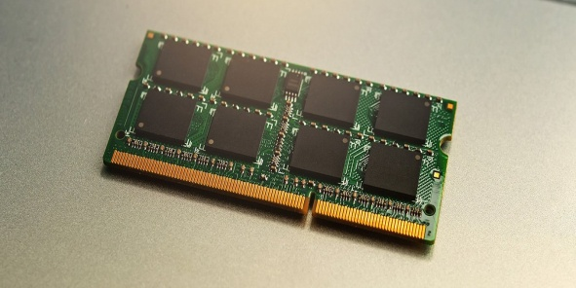

The hardware above is called ___________

a. PRAM b.RAM c. ROM d. floppy disk

46. The following are component of the system unit EXCEPT____ a. RAM b. Monitor c. CPU d. Hard disk

47. 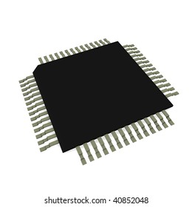

The diagram above is called _______

a. ROM b. IC c. transistor d. RAM

48. The following are example of operating system EXCEPT ______ a. Windows 7 b. MS-Word c. MAC OS d. UNIX

49. __________ are the computer user that are not certified but can also use the computer to perform some basic computational task like playing music, watching video and playing games.

a. professionals b. End Users c. web designers d. computer teachers

50. __________ is the principal storage of the computer.

a. RAM b. memory unit

c. ROM d. hard disk

**THEORY**

**Answer four[4] question from this section. Question one is compulsory**

1a.Define an operating system (2marks)

b. List and explain four types of operating system (8marks)

c. Mention five functions of an operating system (5marks)

2a. List and explain the classification of computer by types of data processed (9marks)

b. State the item used in building the 4th generation of computer (1marks)

3a. What do you understand by computer system? (2marks) b. Distinguish between the following pair of terms; with *two* examples each

* System software and application software (4marks)
* Input and output devices (4 marks)

4a.State*four* and explain *three* classification of computer by size. [5 marks]

b. State three units of storage and their values

.[3 marks]

c. With the aid of a diagram, illustrate the computer system. [2 marks ]

5a. What are Peopleware? (1marks)

b. List and explain the two types of people ware with two examples each (4marks)

c. Highlight 5 characteristic of a computer.

[5 marks]

6a.Distinguish between kilobyte and gigabyte (4marks)

b. Convert the following hexadecimal to

1. 16516 (2marks)

2. 5458 (2 marks)

3. Convert 20GB to megabyte (2marks)